**Searching Algorithms Questions**

**Question 1:**

**Show the stages of a linear search to find the word “Amsterdam” in the following list:**

**Jakarta London Cairo Minsk Amsterdam Bangkok**

**Question 2:**

**Show the stages of a binary search to find the name “Matthew” when applied to the data below:**

**Alice Carol Catherine David Francesca Jane Mary Matthew Maureen**

**Question 3:**

**Why would a binary search not be possible on the following data?**

**2,3,7,5,13,11**

**Question 4:**

**Study the following code.**

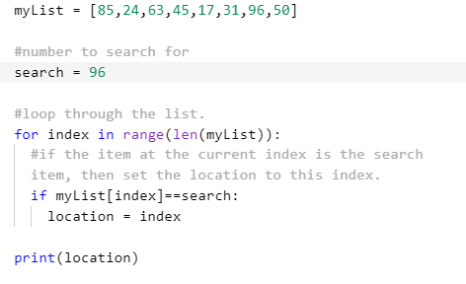

**What will the program output?**

**Question 5**

**Study the following code:**

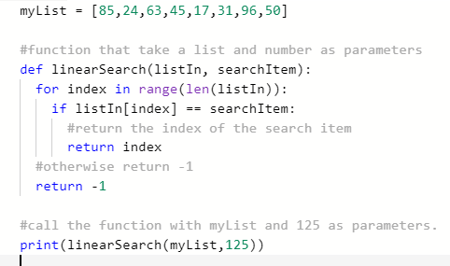

**What will the program output?**

**What would the output be if the last line of the program was changed to**

print(linearSearch(myList, 31))

**Question 6**

**Study the following code:**

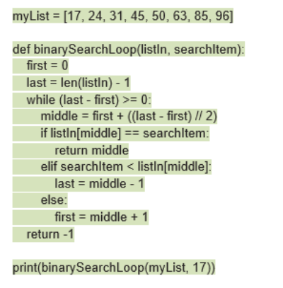

**What will the output be?**

**What would the output be if the last line of the program was changed to**

print(binarySearchLoop(myList, 63))?

**Write out the stages that the program would go through to get to this output (similar to Q2. Keep track of what the variables first, last and middle are at each stage.**